900221-000-00-KM-02, Python Data Types and Structures, NQF Level 4, Credits 6
Facilitator Guide
Module Two (2)

Module Code | 900221-000-00-KM-02
NQF Level | 4
Credits | 6
Skills Programme ID Number | SP- 230375
Curriculum Title | Java Programmer
Curriculum Code | 900221-000-00-00

Name
Contact Address
Telephone (H)
Telephone (W)
Facsimile
Cellular
E-mail

Note to the learner
This Learner Guide provides a comprehensive overview of the module. It is designed to improve the skills and knowledge of learners, and thus enabling them to effectively and efficiently complete specific tasks.

Purpose of the Module
The main focus of the learning in this knowledge module is to build an understanding of the functionalities of Python data type and structures and when/how to use them
The learning will enable learners to demonstrate an understanding of:
- KM-02-KT01: Python strings 15%
- KM-02-KT02: Numbers in Python 10%
- KM-02-KT03: Float in Python 10%
- KM-02-KT04: Double data types in Python 5%
- KM-02-KT05: Boolean in Python 10%
- KM-02-KT06: Python List15%
- KM-02-KT07: Python tuplem 10%
- KM-02-KT08: Dictionary in Python10%
- KM-02-KT09: Python sets5%
- KM-02-KT10: Arrays in Python 10%

Provider Accreditation Requirements for the Knowledge Module
Physical Requirements:
- The provider must have lesson plans and structured learning material or provide learners with access to structured learning material that addresses all the topics in all the knowledge modules as well as the applied knowledge in the application.
- QCTO/ MICT SETA requirements

Human Resource Requirements:
Lecturer/learner ratio of 1:20 (Maximum)
- Qualification of lecturer (SME): o NQF 5 qualified in industry recognised qualifications with 1-year experience in the IT industry
- Cybersecurity vendor certification • Assessors and moderators: accredited by the MICT SETA

Legal Requirements:
- Legal (product) licences to use the software for learning and training
- OHS compliance certificate

Venue, Date and Time:
Consult your facilitator should there be any changes to the venue, date and/or time.Refer to your timetable.

Assessments
Integrated Formative Assessment: The skills development provider will use the curriculum to guide them on the stipulated internal assessment criteria and weighting. They will also apply the scope of practical skills and applied knowledge as stipulated by the internal assessment criteria. This formative assessment leads to entrance into the integrated external summative assessment.

Integrated Summative Assessment: An external integrated summative assessment conducted through the relevant QCTO Assessment Quality Partner is required to issue this qualification. The external integrated summative assessment will focus on the exit level outcomes and associated assessment criteria.

Skills Programme Rationale
In South Africa, according to the 2020 list of occupations in high demand: Technical Report (Department of Higher Education and Training) published in 2021 it is clear that the role of the programming and its derived skills programmes have been identified as pivotal by several Sector Education and Training Bodies (SETAs). Responding to the rapid skills demand by supplying Python programmers will thus have a positive impact on the economy.
Python programmers will play a pivotal role in establishing a data-driven culture and currently available advanced technology to manipulate these big data and complex datasets.
It is also important to note that there are great opportunities to become self-employed and the entrepreneurial orientated Python Programmers will form new companies (with the employment creation associated to it).
A demand for competent Python programmers exist in any economic sector, e.g. finance, insurance, healthcare, energy, environmental, government, transportation, agriculture and food. International research also confirms the phenomenal growth in the need for qualified programmers, including Python Programmers.
Typical learners include school leavers and persons who want to enter the ICT sector with programming skills. Minimum requirements are a Gr 11 with Maths Lit and English.

Skills Programme Purpose
A Python Programmer will be able to implement solutions to solve real-life problems in an efficient manner applying a knowledge and understanding of the principles of programming with Python and applicable tools.
Tasks that the learner will be able to know, do and understand after achievement of the skills programme include:
- Create well-written and readable Python programs, using a disciplined coding style, including comments and indentation standards.
- Work collaboratively in a team and execute version control.

Entry Requirements
- Grade 11 with Maths Lit and English.
- Access to equipment, internet connectivity and how to work remotely

EXIT LEVEL OUTCOMES

Exit Level Outcomes (ELO) 1
Describe the basics of Python Programming
Associated Assessment Criteria
- Fundamentals of the Python programming language are explained.
- The basic concepts and methods of object-oriented programming and object-oriented design are described.
- The development life cycle as a means of creating applications is described.

Exit Level Outcomes (ELO) 2
Programme effectively using Python frameworks and functionalities
Associated Assessment Criteria
- The use of Python syntax, using the Python API is applied.
- Well-written and readable Python programs are created, using a disciplined coding style, including documentation and indentation standards.
- The ability to troubleshoot problems with application development is applied.

Exit Level Outcomes (ELO) 3
Work collaboratively in a team using GitHub platform
Associated Assessment Criteria
- An ability to work with Git and GitHub functionalities is demonstrated.
- The ability to work collaboratively in a team using Git is applied
- Version control is executed using Git functionalities such as repositories, branches, commits and pull requests.

Session 1: KM-02-KT01: Python strings 15%
- IAC0101 Explain the definitions, functions and features of Python strings

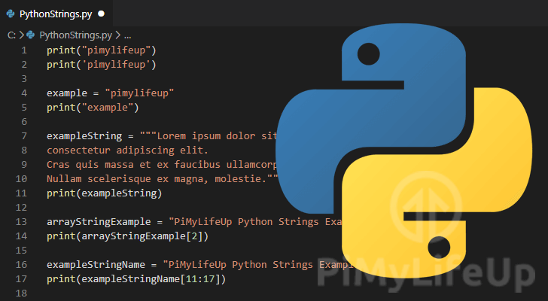
Concept of Python Strings:
In Python, a string is a sequence of characters enclosed within either single (' '), double (" "), or triple (''' ''' or """ """) quotes. Strings are one of the most commonly used data types in Python and are essential for representing and manipulating text.
Definition of Python Strings:
A Python string is a collection of characters, where each character has an index, starting from 0 for the first character. Strings are immutable in Python, which means that once you create a string, you cannot change its content; instead, you create a new string.
Here's how you can define strings in Python:
single_quoted_string = 'Hello, World!' # Using single quotes double_quoted_string = "Python is great." # Using double quotes triple_quoted_string = '''This is a multi-line string.''' # Using triple quotes
Functions and Methods for Python Strings:
Python provides a wide range of built-in functions and methods for working with strings. Here are some common functions and methods for manipulating strings:
- String Concatenation:
  - You can concatenate (combine) strings using the + operator.
first_name = "John" last_name = "Doe" full_name = first_name + " " + last_name # Concatenate two strings
- String Length:
  - To get the length (number of characters) of a string, you can use the len() function.
text = "Hello, World!" length = len(text) # Get the length of the string
- String Indexing:
  - You can access individual characters in a string using indexing, where the first character is at index 0.
text = "Python" first_character = text[0] # Get the first character
- String Slicing:
  - Slicing allows you to extract a portion of a string by specifying a range of indices.
text = "Python Programming" substring = text[7:18] # Extract "Programming"
- String Methods:
  - Python provides various string methods for common operations like converting to uppercase, lowercase, splitting, stripping whitespace, and more.
text = " Python Programming " uppercase_text = text.upper() # Convert to uppercase lowercase_text = text.lower() # Convert to lowercase stripped_text = text.strip() # Remove leading and trailing whitespace words = text.split() # Split into a list of words
- String Formatting:
  - Python offers multiple ways to format strings, including f-strings (formatted strings), the str.format() method, and the % operator.
name = "Alice" age = 30 formatted_string = f"My name is {name} and I am {age} years old."
These are just some of the basic functions and methods for working with Python strings. Strings are incredibly versatile in Python and can be used for tasks ranging from simple text manipulation to more complex text processing and parsing.

Session 2: KM-02-KT02: Numbers in Python 10%
- IAC0201 Determine the definitions, functions and features of numbers in Python
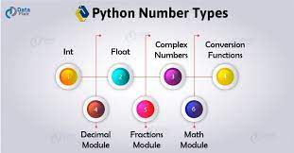
In Python, numbers are fundamental data types used for representing numeric values. There are several types of numbers in Python, including integers, floating-point numbers, and complex numbers. Here's an overview of numbers in Python:
1. Integers (int):
- Integers represent whole numbers, both positive and negative, without a fractional or decimal component.
- Example: 5, -10, 0
2. Floating-Point Numbers (float):
- Floating-point numbers represent real numbers with a fractional part. They can also represent very large or very small numbers using scientific notation.
- Example: 3.14, 2.0, 1.23e-4
3. Complex Numbers (complex):
- Complex numbers consist of a real part and an imaginary part. They are represented as a + bj, where a is the real part and b is the imaginary part.
- Example: 2 + 3j, -1.5 - 2.7j
Functions and Operations with Numbers in Python:
Python provides a wide range of functions and operations for working with numbers. Here are some common functions and operations:
Arithmetic Operations:
- Python supports basic arithmetic operations such as addition (+), subtraction (-), multiplication (*), division (/), exponentiation (**), and modulus (%).
x = 5 y = 2 addition = x + y # 7 subtraction = x - y # 3 multiplication = x * y # 10 division = x / y # 2.5 exponentiation = x ** y # 25 modulus = x % y # 1
Type Conversion:
- You can convert between different numeric types using functions like int(), float(), and complex().
num_str = "42" int_num = int(num_str) # Convert a string to an integer float_num = float(int_num) # Convert an integer to a floating-point number complex_num = complex(int_num, float_num) # Create a complex number
Math Functions:
- Python's math module provides a wide range of mathematical functions, including sqrt(), abs(), sin(), cos(), tan(), and many more.
import math square_root = math.sqrt(25) # 5.0 absolute_value = abs(-7) # 7 sine_value = math.sin(math.radians(30)) # 0.5 (sin of 30 degrees)
Comparison and Logical Operators:
- You can use comparison operators (<, >, <=, >=, ==, !=) and logical operators (and, or, not) to compare and manipulate numeric values.
x = 5 y = 10 is_greater = x > y # False is_equal = x == y # False logical_result = (x < 10) and (y > 0) # True
Numbers play a crucial role in scientific and mathematical computing, as well as in various programming tasks. Understanding how to work with numbers and perform numeric operations is fundamental in Python programming.

Session 3: KM-02-KT03: Float in Python 10%
- IAC0301 Explain the definitions, functions and features of Python float

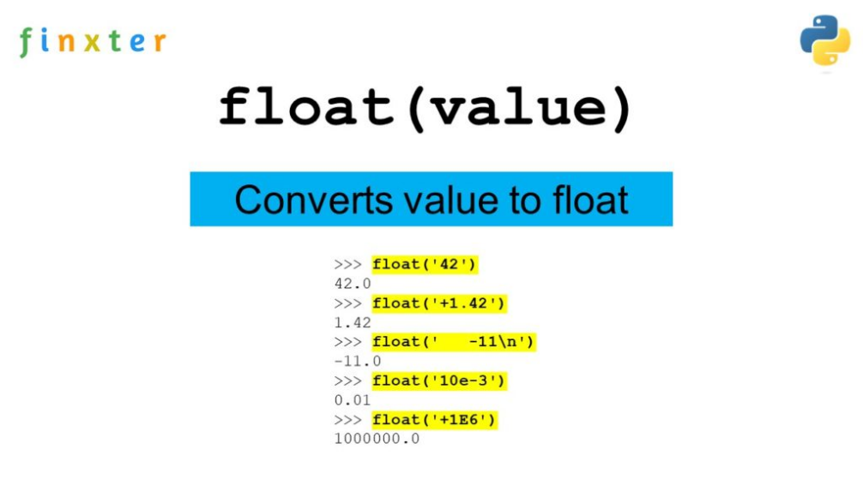
In Python, a "float" refers to a data type used to represent decimal or floating-point numbers. Floats are used to store real numbers, including integers and numbers with fractional parts. Here, I'll explain the concept, definition, and functions related to floats in Python.
- Concept and Definition:
  - Floats: Floats are a fundamental data type in Python used to represent real numbers. They are called "floating-point" because the decimal point can float or move within the number, allowing for a wide range of values, including integers and fractions.
  - Floats can be positive or negative and can have decimal points or be expressed in scientific notation (e.g., 3.14 or 2.5e-3).
  - Python uses the IEEE 754 standard to represent floating-point numbers, which is a widely adopted standard for floating-point arithmetic.
- Functions Related to Floats:
a. Creating Floats:
  - To create a float in Python, you can simply write a number with a decimal point, e.g., 3.14 or -0.25.
  - You can also use the float() constructor to convert other data types to floats. For example:
x = float(5) # Converts the integer 5 to a float (5.0)
b. Mathematical Operations:
  - Floats can be used in various mathematical operations such as addition, subtraction, multiplication, and division.
a = 3.0 b = 1.5 sum_result = a + b
c. Conversion:
  - You can convert a float to an integer using int(). This will truncate the decimal part.
x = int(3.9) # Converts the float 3.9 to an integer (3)
d. Comparison:
  - You can compare floats using comparison operators like <, >, <=, >=, ==, and !=.
x = 3.0 y = 2.5 if x > y: print("x is greater than y")
e. Formatting:
  - You can format float values for display using various formatting options, such as f-strings, format(), or the % operator.
value = 42.12345678 print(f"Formatted value: {value:.2f}") # Displays value rounded to 2 decimal places
These are some of the fundamental concepts, definitions, and functions related to floats in Python. Floats are essential for performing arithmetic operations involving real numbers and are commonly used in scientific and mathematical applications.

Session 4: KM-02-KT04: Double data types in Python 5%
- IAC0401 Identify and explain the definitions, functions and features of Python double data types

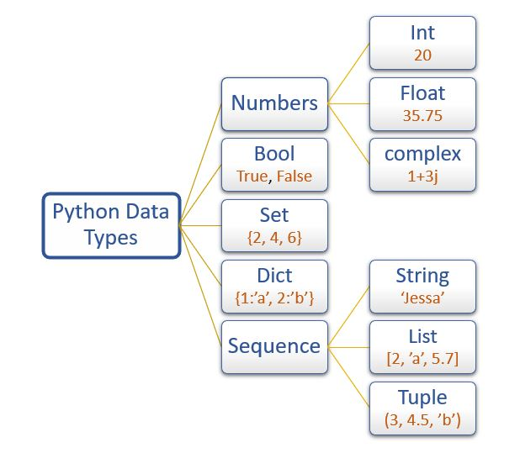
In Python, there is no distinct "double" data type as you would find in some other programming languages like C++ or Java. Instead, Python uses a floating-point representation based on the IEEE 754 standard, and this representation is used to store both single-precision and double-precision floating-point numbers. Here's an explanation of the concept, definition, and functions related to double-precision floating-point numbers in Python:
1. Concept and Definition:
- In Python, floating-point numbers are used to represent real numbers, including both integers and numbers with fractional parts.
- Python uses the IEEE 754 standard, which includes both single-precision and double-precision representations.
- Double-precision, also known as "double," refers to a higher-precision floating-point format that uses 64 bits to represent a floating-point number. It provides greater precision than single-precision (32-bit) floats.
- Python uses double-precision by default for its float data type, ensuring high precision for most practical purposes.
2. Functions Related to Double-Precision Floating-Point Numbers (Floats in Python):
a. Creating Double-Precision Floats: - In Python, you can create double-precision floating-point numbers simply by writing a number with a decimal point. Python automatically uses double-precision for floating-point values. python double_value = 3.141592653589793
b. Mathematical Operations: - Double-precision floats can be used in various mathematical operations, such as addition, subtraction, multiplication, and division. python a = 3.141592653589793 b = 2.718281828459045 sum_result = a + b
c. Comparison: - You can compare double-precision floats using comparison operators like <, >, <=, >=, ==, and !=. python x = 3.141592653589793 y = 2.718281828459045 if x > y: print("x is greater than y")
d. Conversion: - You can convert other data types to double-precision floats using the float() constructor. For example: python x = float(5) # Converts the integer 5 to a double-precision float (5.0)
e. Formatting: - You can format double-precision float values for display using various formatting options, such as f-strings, format(), or the % operator. python value = 42.123456789012345 print(f"Formatted value: {value:.4f}") # Displays value rounded to 4 decimal places
f. Special Values: - Python supports special float values like inf (infinity) and nan (not-a-number) for exceptional cases in calculations.
Double-precision floating-point numbers in Python provide high precision and are suitable for most practical use cases involving real numbers. They are used extensively in scientific computing, engineering, data analysis, and various other domains where precise numerical computations are required.

Session 5: KM-02-KT05: Boolean in Python 10%
- IAC0501 Explain the definitions, functions and features of Python Boolean

In Python, a Boolean is a data type used to represent two values: True and False. Booleans are used for logical operations, comparisons, and conditional statements. Here's an explanation of the concept, definition, and functions related to Booleans in Python:
1. Concept and Definition:
- Booleans are a fundamental data type in Python that represents truth values: True and False. These values are used to make logical decisions in programs.
- Booleans are named after the mathematician George Boole, who developed Boolean algebra, a branch of mathematics dealing with logical expressions and operations.
- Booleans are often used to control program flow and make decisions based on conditions.
2. Functions Related to Booleans:
a. Logical Operations: - Python provides several logical operators for working with Boolean values: - and: Returns True if both operands are True. - or: Returns True if at least one operand is True. - not: Returns the opposite Boolean value of the operand.
```python x = True y = False result_and = x and y # Result is False result_or = x or y # Result is True result_not_x = not x # Result is False ```
b. Comparison Operators: - Comparison operators compare values and return Boolean results: - ==: Returns True if the values are equal. - !=: Returns True if the values are not equal. - <, >, <=, >=: Compare numerical or string values and return Boolean results.
```python a = 5 b = 10 equal_result = (a == b) # Result is False not_equal_result = (a != b) # Result is True ```
c. Conditional Statements: - Booleans are frequently used in conditional statements like if, elif, and else to control program flow based on certain conditions.
```python temperature = 25 if temperature > 30: print("It's hot outside.") elif temperature <= 30 and temperature > 15: print("The weather is pleasant.") else: print("It's cold outside.") ```
d. Boolean Functions: - Python has built-in functions that return Boolean values: - isinstance(): Checks if an object is an instance of a specified class. - bool(): Converts a value to its Boolean equivalent.
```python x = 10 is_integer = isinstance(x, int) # Result is True boolean_value = bool(0) # Result is False ```
e. Membership Testing: - The in and not in operators are used to test for membership in sequences (e.g., lists, strings, dictionaries) and return Boolean results.
```python my_list = [1, 2, 3, 4, 5] is_present = 3 in my_list # Result is True not_present = 6 not in my_list # Result is True ```
These are some of the key concepts, definitions, and functions related to Booleans in Python. Booleans are essential for controlling program logic, making decisions, and performing comparisons, which are fundamental aspects of programming.

Session 6: KM-02-KT06: Python List15%
- IAC0601 Define the functions and features of Python list

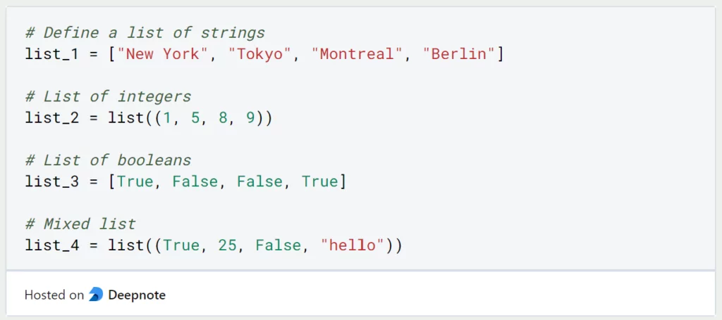
In Python, a list is a versatile and commonly used data structure that allows you to store a collection of elements. Lists are mutable, ordered, and can contain elements of different data types. Here's an explanation of the concept, definition, and key functions related to Python lists:
1. Concept and Definition:
- A list in Python is an ordered collection of elements enclosed in square brackets [].
- Lists can store elements of various data types, including numbers, strings, other lists, and more.
- Lists are mutable, which means you can modify their contents by adding, removing, or updating elements.
2. Creating Lists:
- Lists can be created in several ways:
  - By enclosing elements in square brackets, separated by commas.
  - Using the list() constructor to convert other iterable objects (e.g., tuples, strings) into lists.
# Creating a list fruits = ["apple", "banana", "cherry"] numbers = [1, 2, 3, 4, 5] empty_list = []
3. Accessing Elements:
- Elements in a list are accessed using their index, starting from 0 for the first element.
- Negative indices count from the end of the list (-1 for the last element).
print(fruits[0]) # "apple" print(fruits[-1]) # "cherry"
4. List Operations:
- Lists support various operations, including:
  - Concatenation (+): Combining two lists into one.
  - Repetition (*): Repeating a list's elements.
  - Length (len()): Finding the number of elements in a list.
combined_list = fruits + numbers repeated_list = fruits * 3 list_length = len(fruits)
5. Modifying Lists:
- Lists can be modified by:
  - Appending elements to the end using append().
  - Inserting elements at a specific index using insert().
  - Removing elements using methods like remove(), pop(), or del.
fruits.append("orange") fruits.insert(1, "grape") fruits.remove("banana") popped_element = fruits.pop(2) del fruits[0]
6. List Slicing:
- You can extract a portion of a list using slicing, which involves specifying a start, stop, and step.
sliced_list = fruits[1:3] # ["grape", "cherry"]
7. List Comprehensions:
- List comprehensions provide a concise way to create lists by applying an expression to each item in an iterable.
squares = [x**2 for x in numbers]
8. Common List Functions:
- Python provides built-in functions like max(), min(), sum(), and sorted() to work with lists.
max_value = max(numbers) min_value = min(numbers) total = sum(numbers) sorted_list = sorted(numbers)
9. List Methods:
- Lists have several built-in methods, such as append(), extend(), count(), index(), and sort(), which allow you to manipulate and work with lists efficiently.
fruits.append("apple") fruits.extend(["kiwi", "mango"]) apple_count = fruits.count("apple") index_cherry = fruits.index("cherry") fruits.sort()
Python lists are a fundamental data structure that is widely used in various programming scenarios for storing, manipulating, and processing collections of data. Understanding lists and their functions is essential for Python programming.

Session 7: KM-02-KT07: Python tuplem 10%
- IAC0701 Determine the definitions, functions and features of Python tuple
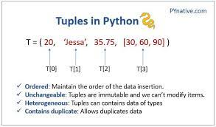
A tuple in Python is a collection of ordered, immutable elements. Tuples are similar to lists, but with a key difference: once you create a tuple, you cannot modify its elements. This immutability makes tuples useful in situations where you want to ensure that the data remains constant and cannot be changed accidentally. Here are the key concepts, definitions, and functions related to tuples in Python:
Concept and Definition:
- A tuple is created by enclosing a comma-separated sequence of elements within parentheses (). For example:
my_tuple = (1, 2, 3)
- Tuples can also be created without parentheses, provided there's a comma between the elements:
my_tuple = 1, 2, 3
- Elements in a tuple can be of different data types, and they can be heterogeneous. For example:
mixed_tuple = (1, "apple", True, 3.14)
- Tuples are indexed, and you can access individual elements using square brackets and indices, just like in lists.
print(my_tuple[0]) # Output: 1 print(my_tuple[1]) # Output: 2
Tuple Functions and Methods:
- len(): You can use the len() function to determine the number of elements in a tuple.
my_tuple = (1, 2, 3) length = len(my_tuple) # length will be 3
- count(): The count() method is used to count the number of occurrences of a specified value within a tuple.
my_tuple = (1, 2, 2, 3, 4, 2, 5) count = my_tuple.count(2) # count will be 3
- index(): The index() method is used to find the index (position) of the first occurrence of a specified value within a tuple.
my_tuple = (10, 20, 30, 40, 50, 20, 60) index = my_tuple.index(20) # index will be 1
Immutability: One crucial feature of tuples is their immutability. Once a tuple is created, you cannot change, add, or remove elements from it. This ensures that the data within a tuple remains constant.
my_tuple = (1, 2, 3) # Attempting to modify the tuple will result in an error: # my_tuple[0] = 10 # This will raise a TypeError
Tuples are often used when you want to ensure data integrity or when you need a collection of values that should not be modified accidentally during program execution. They are commonly used for returning multiple values from functions and in situations where the order of data matters.

Session 8: KM-02-KT08: Dictionary in Python10%
- IAC0801 Explain the definitions, functions and features of Python dictionaries
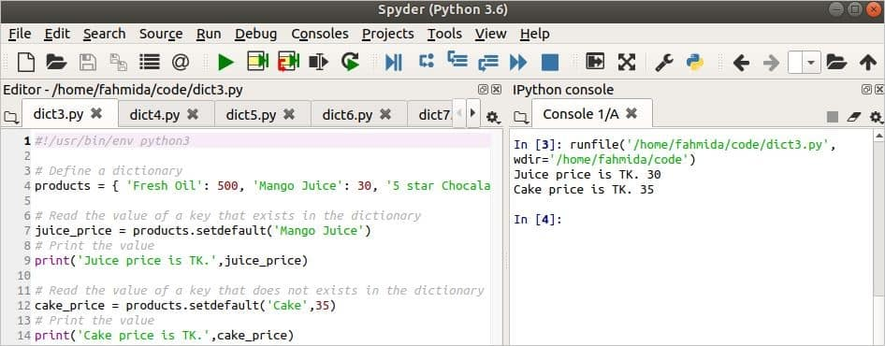
In Python, a dictionary is a built-in data type that represents a collection of key-value pairs. Dictionaries are also known as associative arrays or hash maps in other programming languages. They are versatile and widely used for storing and organizing data. Here's the concept, definition, and some common functions associated with dictionaries in Python:
Concept and Definition:
- A dictionary is an unordered collection of data that is indexed by keys.
- Each key in a dictionary is unique and maps to a specific value.
- Keys in a dictionary are typically strings, numbers, or other immutable (unchangeable) types.
- Values in a dictionary can be of any data type, including numbers, strings, lists, tuples, other dictionaries, or even custom objects.
- Dictionaries are enclosed in curly braces {} and consist of key-value pairs separated by colons. For example:
my_dict = {"name": "Alice", "age": 30, "city": "New York"}
- You can access the values in a dictionary by referencing their keys:
name = my_dict["name"] # Accessing the value associated with the key "name"
Common Functions and Methods:
- len(): The len() function returns the number of key-value pairs (items) in a dictionary.
my_dict = {"name": "Alice", "age": 30, "city": "New York"} length = len(my_dict) # length will be 3
- keys(): The keys() method returns a view object that displays a list of all the keys in the dictionary.
my_dict = {"name": "Alice", "age": 30, "city": "New York"} keys_list = list(my_dict.keys()) # keys_list will be ["name", "age", "city"]
- values(): The values() method returns a view object that displays a list of all the values in the dictionary.
my_dict = {"name": "Alice", "age": 30, "city": "New York"} values_list = list(my_dict.values()) # values_list will be ["Alice", 30, "New York"]
- items(): The items() method returns a view object that displays a list of all key-value pairs (tuples) in the dictionary.
my_dict = {"name": "Alice", "age": 30, "city": "New York"} items_list = list(my_dict.items()) # items_list will be [("name", "Alice"), ("age", 30), ("city", "New York")]
- get(): The get() method allows you to retrieve the value associated with a key, with the option to specify a default value if the key does not exist in the dictionary.
my_dict = {"name": "Alice", "age": 30, "city": "New York"} name = my_dict.get("name", "Unknown") # name will be "Alice" profession = my_dict.get("profession", "Unknown") # profession will be "Unknown" since "profession" key does not exist
These are some of the essential concepts and functions associated with dictionaries in Python. Dictionaries are powerful data structures that are widely used for various purposes, including data storage, data retrieval, and organizing data in key-value pairs.

Session 9: KM-02-KT09: Python sets5%
- IAC0901 Define the functions and features of Python sets
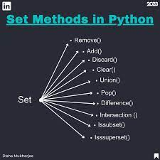
A set is a built-in data type in Python that represents an unordered collection of unique elements. In other words, a set contains values, but each value can only appear once in a set. Sets are commonly used for tasks that involve storing and managing distinct items or checking for the presence of specific elements. Here are the concept, definition, and some functions associated with sets in Python:
Concept and Definition:
- A set is an unordered collection of unique elements.
- Sets are defined using curly braces {} or the set() constructor.
- Elements in a set are separated by commas.
- Sets are mutable, which means you can add and remove elements after the set is created.
Here's an example of creating a set:
my_set = {1, 2, 3, 4, 5}
In this set, {1, 2, 3, 4, 5}, all elements are unique, and they are stored in an unordered manner.
Common Functions and Methods:
- len(): The len() function returns the number of elements in a set.
my_set = {1, 2, 3, 4, 5} length = len(my_set) # length will be 5
- add(element): The add() method is used to add a single element to a set.
my_set = {1, 2, 3} my_set.add(4) # Adds the element 4 to the set
- update(iterable): The update() method is used to add multiple elements to a set from an iterable (e.g., a list, tuple, or another set).
my_set = {1, 2, 3} my_set.update([3, 4, 5]) # Adds elements 4 and 5 to the set
- remove(element): The remove() method removes a specified element from the set. If the element is not in the set, it raises a KeyError.
my_set = {1, 2, 3} my_set.remove(2) # Removes the element 2 from the set
- discard(element): The discard() method also removes a specified element from the set, but it does not raise an error if the element is not in the set.
my_set = {1, 2, 3} my_set.discard(4) # Does nothing since 4 is not in the set
- pop(): The pop() method removes and returns an arbitrary element from the set. Since sets are unordered, the popped element can be any element from the set.
my_set = {1, 2, 3, 4, 5} popped_element = my_set.pop() # Removes and returns an arbitrary element
- clear(): The clear() method removes all elements from the set, leaving it empty.
my_set = {1, 2, 3} my_set.clear() # Clears all elements, leaving an empty set
- union() and intersection(): You can perform set operations like union and intersection using methods like union() and intersection().
set1 = {1, 2, 3} set2 = {3, 4, 5} union_result = set1.union(set2) # Union of set1 and set2 intersection_result = set1.intersection(set2) # Intersection of set1 and set2
Sets in Python are useful for various tasks, such as removing duplicate values from lists, testing for membership, and performing set operations. They are a fundamental data type that provides efficient methods for working with unique elements.

Session 10: KM-02-KT10: Arrays in Python 10%
- IAC1001 Describe the definitions, functions and features of Python arrays

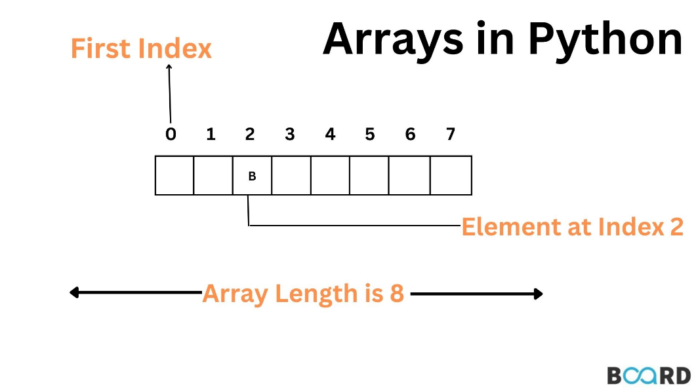
In Python, arrays are homogeneous collections of elements with a fixed size, and they are provided by the array module. Arrays in Python are similar to lists, but unlike lists, the elements in an array must have the same data type. Arrays are more memory-efficient compared to lists when dealing with large amounts of data of the same type. Here are the concept, definition, and some functions associated with arrays in Python:
Concept and Definition:
- An array is a collection of elements, all of the same data type, arranged in a fixed-size sequence.
- Arrays are defined using the array module, which provides the array() constructor.
Here's an example of creating an array in Python:
import array # Creating an integer array my_array = array.array('i', [1, 2, 3, 4, 5])
In this example:
- import array imports the array module.
- array.array('i', [1, 2, 3, 4, 5]) creates an integer array containing the elements 1, 2, 3, 4, and 5.
Common Functions and Methods:
- append(value): Adds a single element to the end of the array.
my_array.append(6)
- extend(iterable): Extends the array by appending elements from an iterable.
my_array.extend([7, 8, 9])
- insert(index, value): Inserts a value at a specified index in the array.
my_array.insert(2, 10) # Inserts 10 at index 2
- remove(value): Removes the first occurrence of a value from the array.
my_array.remove(3) # Removes the first occurrence of 3
- pop(index): Removes and returns the element at the specified index.
popped_element = my_array.pop(1) # Removes and returns the element at index 1
- index(value): Returns the index of the first occurrence of a value in the array.
index = my_array.index(4) # Returns the index of the first occurrence of 4
- count(value): Returns the number of occurrences of a value in the array.
count = my_array.count(2) # Returns the count of occurrences of 2
- reverse(): Reverses the elements of the array in-place.
my_array.reverse() # Reverses the order of elements in the array
- tostring(): Converts the array to a binary string.
binary_string = my_array.tostring() # Converts the array to a binary string
- fromstring(string): Creates an array from a binary string.
new_array = array.array('i') new_array.fromstring(binary_string) # Creates an array from a binary string
These are some of the common functions and methods associated with arrays in Python. Arrays are useful when you need to work with large collections of homogeneous data elements efficiently.

